**WEB OF SCIENCE CATEGORIES**

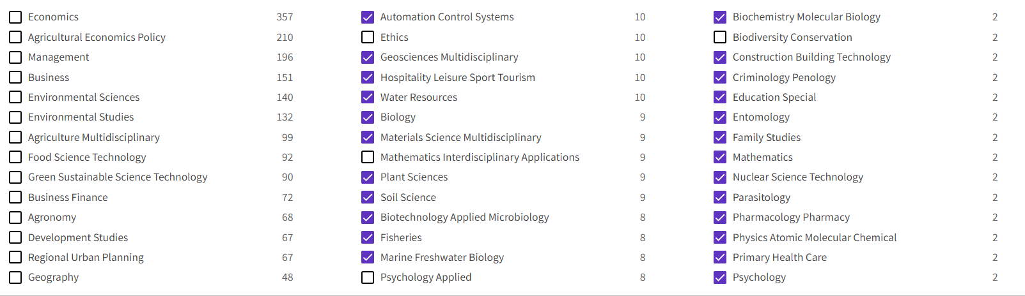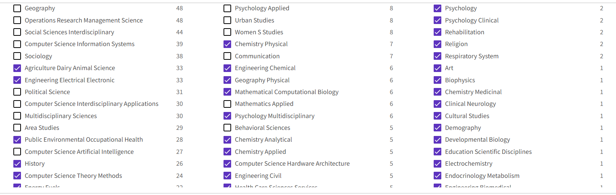

**TOPIC:**

(("Cooperative* Organi*" OR "Co-operative* Organi*"OR “Cooperative Societ*” OR “Co-operative Societ*” OR "Producer* Cooperative*" OR "Producer* Co-operative*" OR "Agr* Cooperative*" OR " Agr* Co-operative*" OR "Farm* Cooperative*" OR "Farm* Co-operative*" OR “Market* Cooperative*” OR “Market* Co-operative*” OR “Sal* Cooperative*” OR “Sal* Co-operative*” OR “Credit Cooperativ*” OR “Credit Co-operativ*”OR "Consumer* Cooperative*"OR " Consumer* Co-operative*" OR "Credit Union*" OR "Credit Mutual*" OR "Sav* Cooperative*" OR "Sav* Co-operativ*"))

And

**TOPIC:**

(Governance OR "Organi* Structure*" OR Board* OR Directo* OR Representat* OR Leader* OR Administrat* OR Management OR "Coordin* Mechan*" OR Incentiv* OR Remuner* OR Control* OR Superv* OR Monitor* OR "Decis* Mak*" OR "CEO Duality" OR Authorit* OR Power OR “Decision Right” OR “Ownership Right” OR “Property Right”)

**PUBLICATION DATE**: 1990-01-01 to 2022-12-31

1,228 results from Web of Science Core Collection